|  |
| --- |
| Practical 11 |
| Develop a database application that uses any JDBC driver |
|  |

Creating Database.

1. Open MicroSoft Access and create Blank Database.

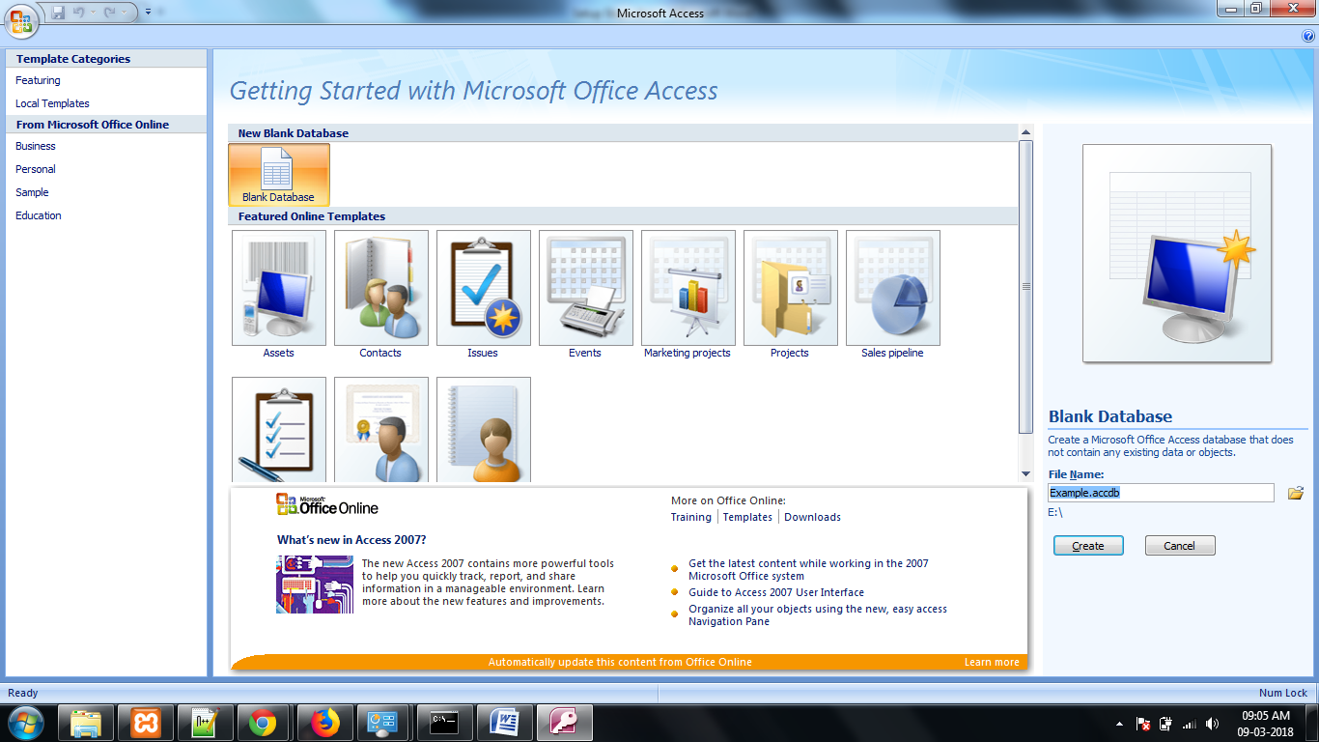

1. Save the database and Enter the name of the Table.

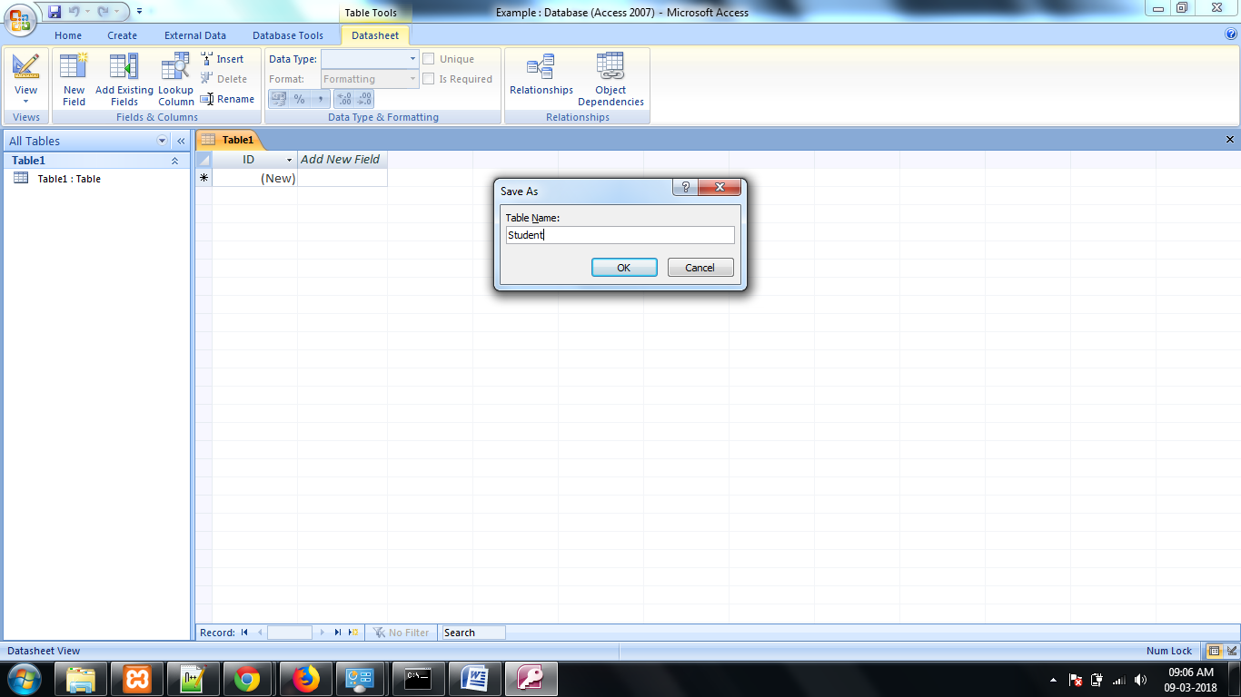

1. Give the column names and save the table.

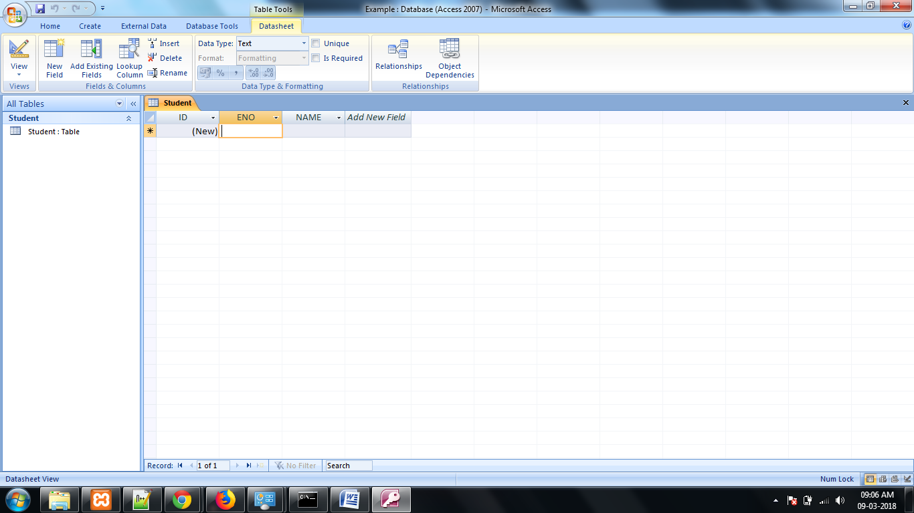

Creating DSN.

1. Open Control Panel.

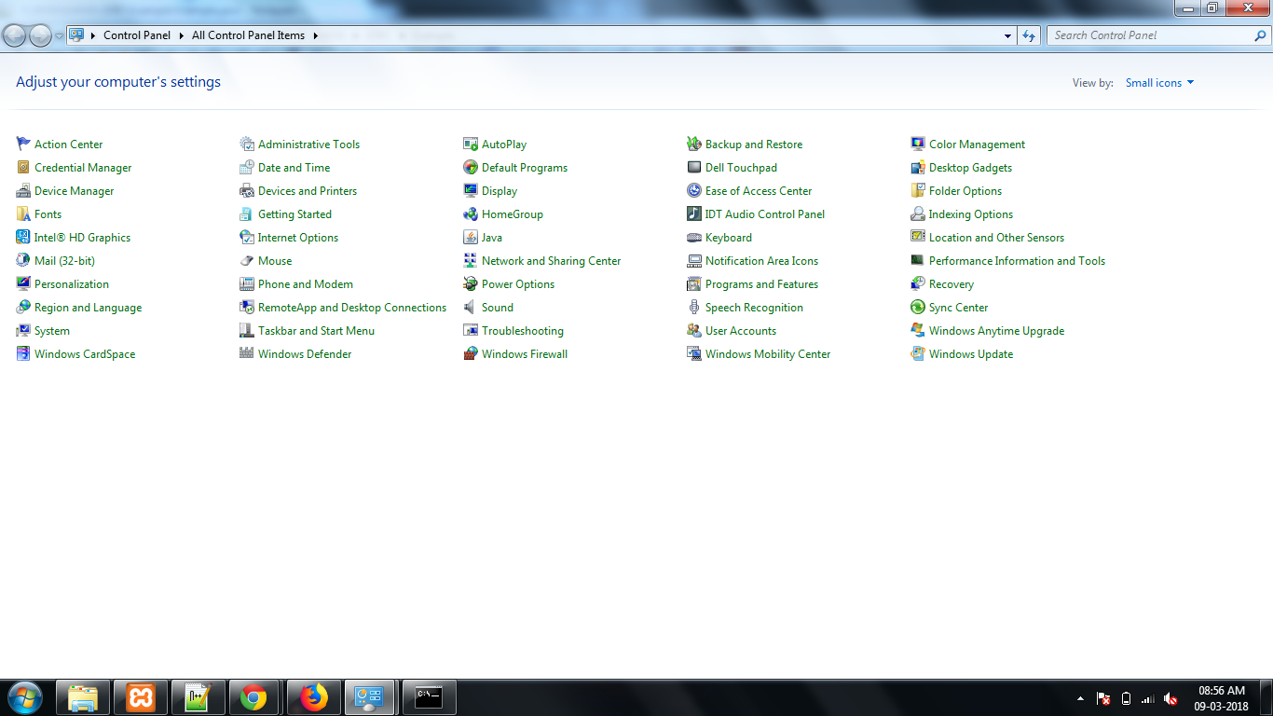

1. Open Administrative Tools.

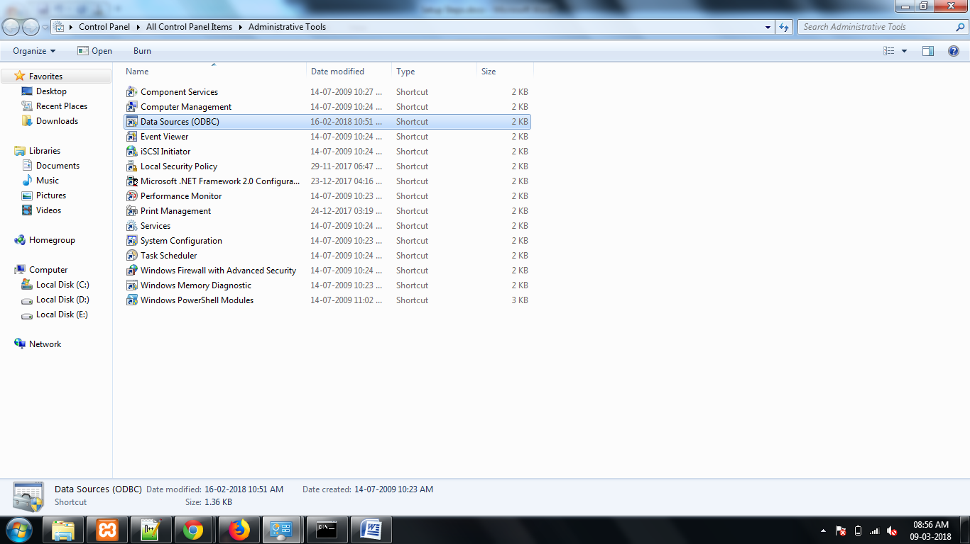

1. Open Data Sources, and Add new DSN.

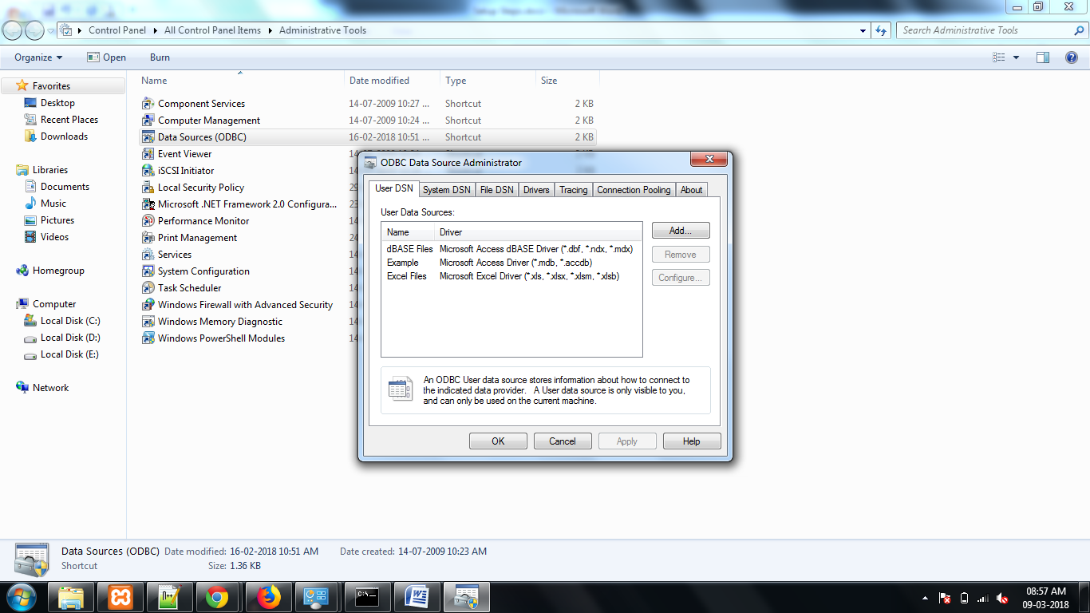

1. Select the Driver, and Click Finish.

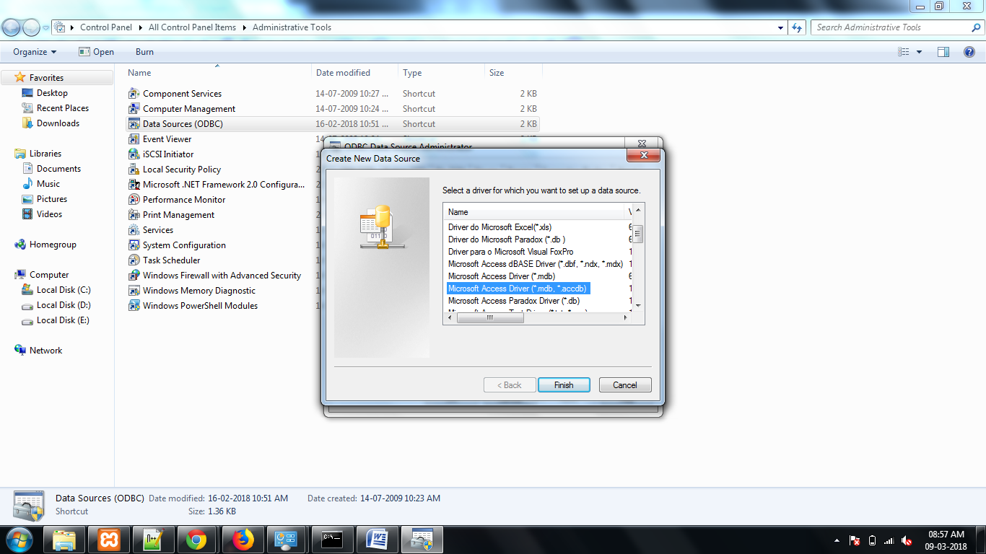

1. Enter the DSN name and Select the Database.

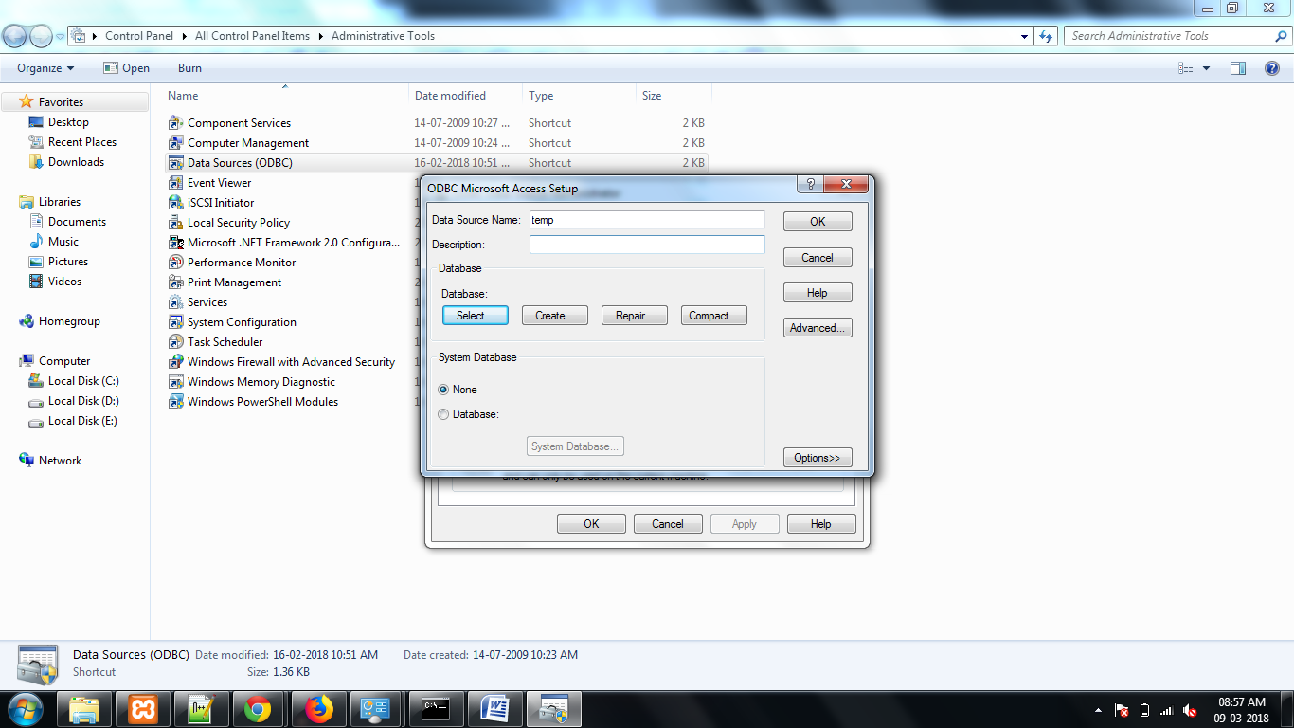

1. Select the drive, and locate the database.

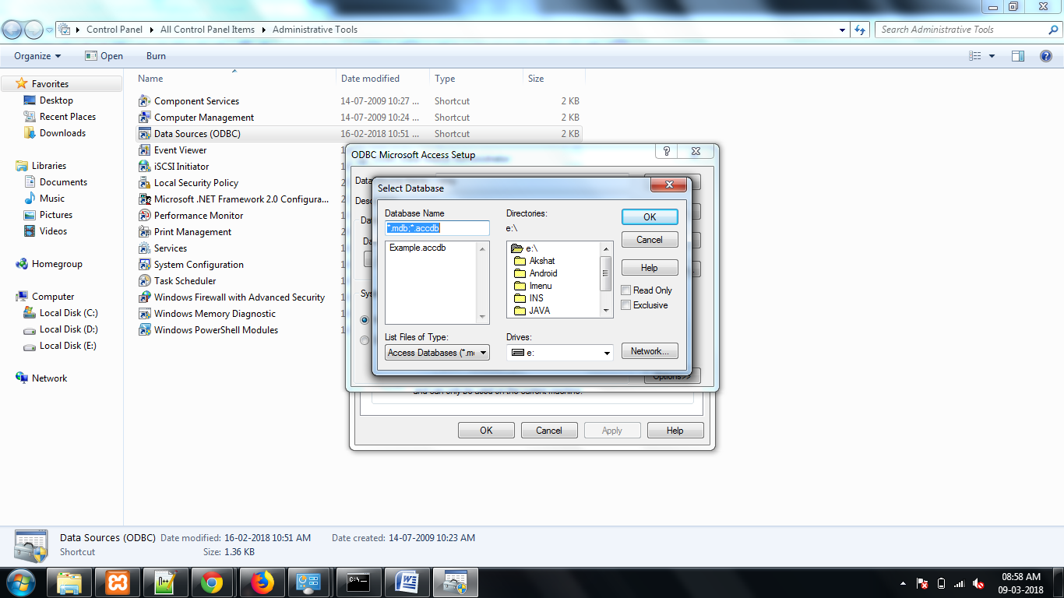

1. Confirm the creation of DSN.

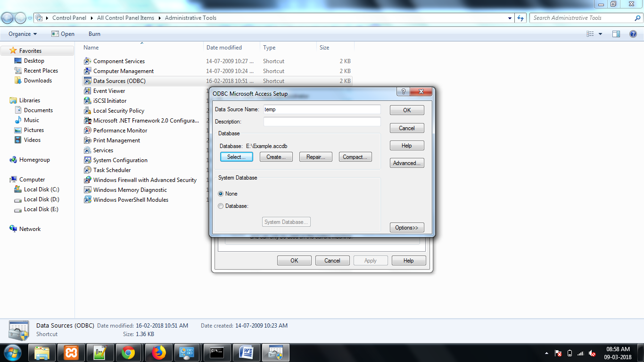

1. DSN will be created with the given.

